INNOVA JUNIOR COLLEGE
JC 2 PRELIMINARY EXAMINATION (2010)
Higher 1 CHEMISTRY

Paper 1 Answers

1 | A | 11 | A | 21 | B
2 | C | 12 | B | 22 | D
3 | D | 13 | A | 23 | C
4 | C | 14 | A | 24 | D
5 | D | 15 | D | 25 | B
6 | C | 16 | A | 26 | A
7 | B | 17 | A | 27 | B
8 | D | 18 | A | 28 | B
9 | C | 19 | B | 29 | D
10 | A | 20 | C | 30 | B

Paper 2 Section A Answers

1 | (a) | (i) | 5Fe²⁺ + MnO₄⁻ + 8H⁺ → 5Fe³⁺ + Mn²⁺ + 4H₂O [1], without s.s
 |  | (ii) | No. of moles of MnO₄⁻ used in the titration = 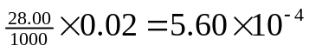
 |  | (iii) | No. of moles of Fe²⁺ in 25.0 cm³ solution  = 5.60 x 10⁻⁴ x 5  = 2.80 x 10⁻³  No. of moles of Fe²⁺ in 250 cm³ solution  = 2.80 x 10⁻³ x 10  = 2.80 x 10⁻²
 |  | (iv) | 2.80 x 10⁻² × Mr = 11.0  Mr = 392.8 OR  ≈ 393
 |  | (v) | [55.8 + 32.0 + 4(16.0) + 2(14 + 4) + 32 + 4(16) + x(18.0) = 393  x = 6
 | (b) | Shape of NH₄⁺:  Shape is tetrahedral.
 | (c) | (i) | Red / brown / pink solid (Cu) forms  Blue solution fades/ become colourless  Zinc dissolves
 |  | (ii) | Assume that the specific heat capacity and density of the solution is similar to that of water.  Energy released = mc∆T  = (75.0)(4.18)(33.7 – 20.5)  = 4138.2 J = 4.14 kJ  No. of moles of Cu formed = 0.42 / 63.5  = 6.61 x 10⁻³  ∆H per mole of copper = - 4.14 / 6.61 x 10⁻³  = -626 kJ

2 | (a) | K_{a} = 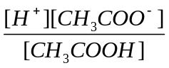
 | (b) | (i) | [H⁺] = 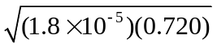  = 3.60 x 10⁻³  pH = - log (3.60 x 10⁻³)  = 2.44
 |  | (ii) | Phenolphthalein. The equivalence point of a weak acid-strong base titration is more than 7, which falls in the working range of the indicator (8 - 10).
 | (c) | In benzene, two molecules of ethanoic acid combine together to form a dimer.  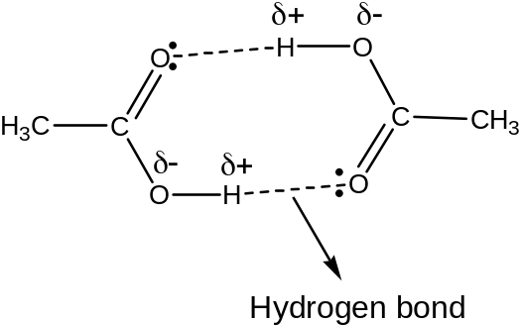

3 | a | (i) | 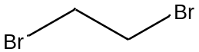
 |  | (ii) | Reagent : Br₂ in CCl₄ OR Br₂(l) ,  Condition : room temp (in the dark)  Type of reaction : Addition
 |  | (iii) | Suggest how succinic acid can be synthesised from compound Q. State the type of reaction involved.
 |  | (iii) | Reagent : Dilute HCl (or H₂SO₄)  Condition : Heat with reflux  Type of reaction : Acidic hydrolysis OR hydrolysis
 |  | (iv) | 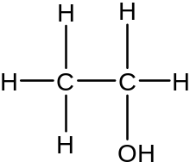  Functional group : primary alcohol
 | (b) | Reagent : Na₂CO₃  Observation :  Succinic acid : Effervescence seen, gas forms white ppt with Ca(OH)₂ (aq)  2-hydroxy-3-methylbutanal : No effervescence seen  OR  Reagent : 2,4-dinitrophenylhydrazine  Observation :  Succinic acid : No orange ppt  2-hydroxy-3-methylbutanal : Orange ppt seen  OR  Reagent : Tollen’s reagent, warm  Observation :  Succinic acid : No silver mirror  2-hydroxy-3-methylbutanal : Silver mirror seen  OR  Reagent : Fehling’s solution, warm  Observation :  Succinic acid : No brick red ppt  2-hydroxy-3-methylbutanal : Brick red ppt and blue Cu²⁺ solution decolourised  OR  Reagent : KMnO₄, dilute H₂SO₄, heat with reflux  Observation :  Succinic acid : Purple colour remains  2-hydroxy-3-methylbutanal: Purple colour of KMnO₄ decolourised

4 |  | (a) |  | (i) |  | Initial rate when [NaOH] = 0.200 mol dm⁻³  = 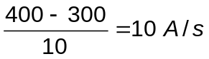  Initial rate when [NaOH] = 0.400 mol dm⁻³  = 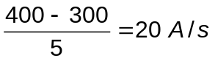  For initial rates values that are outside the range, marks will not be given. However order of reaction can still be awarded.  When [NaOH] doubles, keeping [Y²⁻] constant, the rate also doubles. This implies that the order with respect to NaOH is 1.
 |  |  |  | (ii) |  | From Graph when [NaOH] = 0.200 mol dm⁻³  (show 2 sets of dotted lines to find half life)  The half-life of reaction is approximately constant at 25 sec, hence order of reaction with respect to Y²⁻ is 1  OR  From Graph when [NaOH] = 0.400 mol dm⁻³  (show 2 sets of dotted lines to find half life)  The half-life of reaction is approximately constant at 12.5 sec, hence order of reaction with respect to Y²⁻ is 1.
 |  |  |  | (iii) |  | Rate = k [Y²⁻] [NaOH]
 | (b) |  | (i) |  | MgSiO₃ → MgO + SiO₂
 |  |  | (ii) |  | MgO, SiO₂ and SO₂
 |  |  | (iii) |  | Use concentrated NaOH, both the other acidic oxides will be dissolved, leaving behind MgO/ filter the solution to obtain MgO as residue.  SiO₂ + 2OH⁻ → SiO₃²⁻ + H₂O  SO₂ + 2OH⁻ → SO₃²⁻ + H₂O

Paper 2 Section B Answers

5 | (a) | (i) | No. of moles of ethanoic acid present at equilibrium  = No. of moles of NaOH required  = 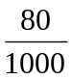x 2 = 0.16
 |  | (ii) | No. of moles of ethanoic acid reacted  = 1 – 0.16 = 0.84
 |  | (iii) | Number of moles of ethanol = 2-0.84 = 1.16  Number of moles of ester formed = 0.84  Number of moles of water formed = 0.84
 |  | (iv) | 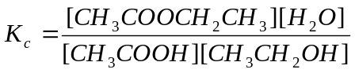
 |  | (v) | 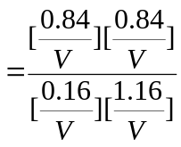  = 3.80
 |  | (vi) | No effect on K_{c} as it is only affected by temperature.
 | (b) | (i) | Reagents: Lithium aluminium hydride, LiAlH₄  Conditions: in dry ether
 |  | (ii) | Type of reaction: Reduction  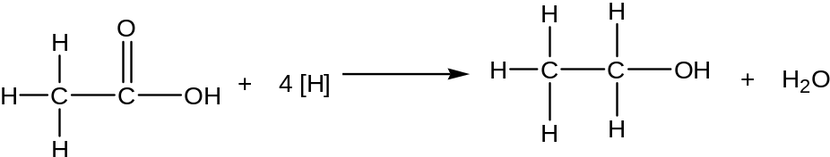
 |  | (iii) | Effervescence observed.
 | (c) | (i) | Phosphorus (III) chloride undergoes hydrolysis with water, to produce steamy HCl fumes and phosphonic acid, H₃PO₃. The solution has a pH = 2
 |  | (ii) | SiCl₄(l) + 2D₂O(l) 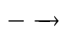 SiO₂(s) + 4DCl(aq)  Or SiCl₄(l) + 4D₂O(l) Si(OD)₄(s) + 4DCl (aq)
 | (d) | (i) | J: Group II element  K: Group III element  Deflection 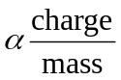  Mass of K⁺ > mass of J⁺  Angle of deflection for of J⁺ > Angle of deflection for of K⁺  NOTE: mark given for working or shown in diagram  +  -  J⁺  K⁺  Source
 |  | (ii) | State and explain which period element J is in and hence identify J.
 |  | (ii) | Based on Figure 5.2, J is in period 3.  Only in period 2-4, atomic number have a difference of 8 down the group.  From period 5, the increase in atomic number down the group is 18.  J is Magnesium

6 | (a) | (i) | Reaction I: NaOH/KOH (aq) reflux  Reaction II: K₂Cr₂O₇ dilute H₂SO₄, distill  Reaction II: HCN trace amount of NaOH/NaCN, 10-20°C
 |  | (ii) | Addition
 |  | (iii) | 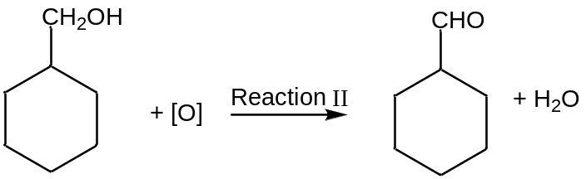
 | (b) | (i) | 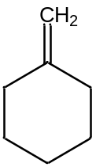
 |  | (ii) | 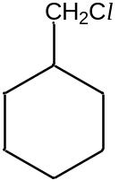
 | (c) | (i) | 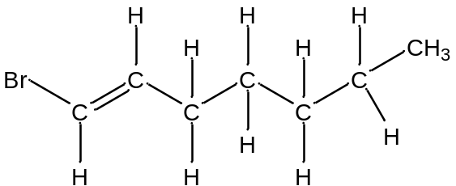  any variation of C₇H₁₃Br and must have cis-trans
 | (ii) | Reagent: Br₂ (aq)  Condition: Room temperature  Observation:  Structural isomer: Orange Br₂(aq) will decolourise  Compound A: Orange Br₂(aq) will not decolourise  OR  Reagent: Liquid Br₂  Condition: Room temperature  Observation:  Structural isomer: Reddish brown Br₂ will decolourise  Compound A: Reddish brown Br₂ will not decolourise  OR  Reagent: KMnO₄  Condition: dilute H₂SO₄, reflux  Observation:  Structural isomer: Purple KMnO₄ will decolourise  Compound A: Purple KMnO₄ will not decolourise
 | (d) | There is comparable number of C and H in compound D, hence, Compound D contains a benzene ring.  Compound D is most likely an alcohol since it is insoluble in sodium hydroxide  It reacts with bromine gas in the dark, hence an alkene is present. It reacts in addition reaction.  Compound E reacts with aqueous potassium hydroxide in substitution reaction.  It contains alcohol group as the compound is neutral.  It reacts with Tollen’s reagent but not Fehling’s solution, hence it contains aromatic aldehyde.  When reacted with potassium manganate (VII), oxidation takes place.  Compound G reacts with Na₂CO₃ via acid-carbonate reaction as it contains carboxylic acid. The effervescence is due to CO_{2.}  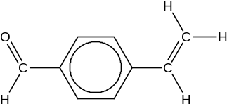Compound D  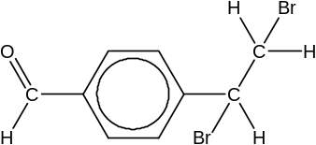Compound E  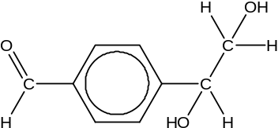Compound F  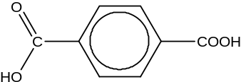Compound G  Accept 1, 2 position and 1,3 position.

7 | (a) | (i) | Chromium forms an inert oxide layer , will protect the metal from corrosion.
 |  | (ii) | Cr₂O₃ (s) + 6H⁺ (aq) → 2Cr³⁺ (aq) + 3H₂O (l)  Cr₂O₃ (s) + 3H₂O (l) + 2OH⁻ (aq) → 2 Cr(OH)₄⁻ (aq)
 | (b) | (i) | H₂O₂ (l) + 2e⁻ → 2OH⁻ (aq)
 |  | (ii) | 2Cr³⁺ (aq) + 10 OH⁻ (aq) + 3H₂O₂ (l) → 2CrO₄²⁻ (aq) + 8H₂O (l)
 |  | (iii) | No. of moles of CrCl₃ = 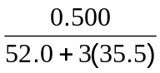= 0.00315 mol  No. of moles of H₂O₂ required = 3/2 x 3.15 x 10⁻³ = 4.73 x 10⁻³ mol  Volume = 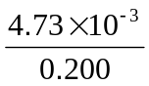 =0.0237 dm³
 | (c) | Shape: Bent
 | (d) | Chlorides of magnesium can conduct electricity in molten and aqueous states, while chlorides of P cannot.  MgCl₂ is has giant ionic structure. In the molten and aqueous states, there are mobile charge carriers (ions), hence able to conduct electricity.  PCl₃ or PCl₅ has a simple molecular structure. In both molten and aqueous states, there no mobile charge carriers, hence unable to conduct electricity.
 | (e) | In the complex [Cr(NH₃)₆]³⁺, the N atom in NH₃ is dative-bond to Co³⁺ ion.  Hence, there are 4 bond pairs and zero lone pairs on N atom.  To minimize repulsion, electron pairs are directed to the 4 corners of a tetrahedron, hence bond angle is about 109.5 º (about 110 º). In an isolated ammonia molecule, there are 3 bond pairs and 1 lone pair. Since lone pair-bond pair repulsion is larger than bond pair-bond pair repulsion, the bond angle is compressed to 107 º.
 | (f) | (i) | K_{c} = [PH₃][BCl₃]
 |  | (ii) | - When temperature is increased, by Le Chatelier’s Principle, equilibrium position shifts to the right to favour the endothermic reaction to absorb additional heat.  - Equilibrium position is unaffected as the addition of solid does not affect the concentration of PH₃ and BCl₃ OR the concentration of solid is constant OR total pressure remains unchanged .

